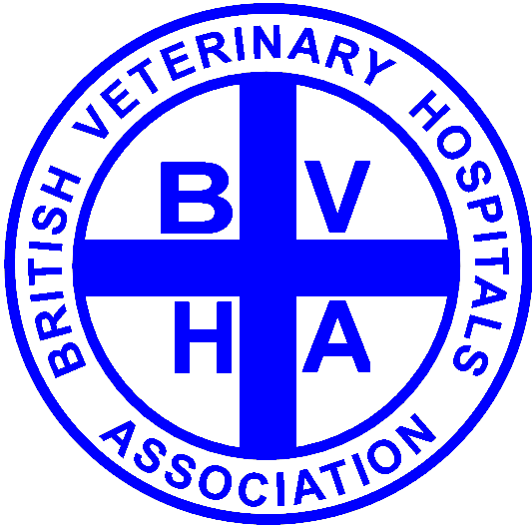
Berlin
BVHA Visiting Weekend
May 4-6, 2018

Details
Name of Delegate……………………………….……………………………………………..BVHA Member:…Y / N….
Practice Name………………………………………………………………………………………………………………………………..
Preferred Contact Address…………………………………………………………………………………………………………….
……………………………………………………………………………Post Code……………………...........................................
Tel No……………………………………………..Email Address……………………………………………………………………….
Any special requirements (e.g. food allergies)……………………………………………………………………………..

Fees
Event | No of Tickets | Cost
BVHA Member: Visiting weekend @ £175 / person
Non BVHA Member: Visiting weekend @ £200 / person
Saturday Evening Dinner in @ £60/ person
Sunday tour of Berlin @ £30 / person

Important Notes
- Accompanying guests who do not wish to go on the tour are not required to pay the visiting weekend fee. However, accompanying guests are most welcome to participate in all events. Guests accompanying a BVHA member participating in the hospital visits will be charged at the BVHA rate.

- In order to allow delegates to choose a room of their preference at the Park Inn by Radisson Hotel in Alexanderplatz, we request that delegates make their own hotel bookings.

- The hotel website is https://www.parkinn-berlin.de/en/ and reservations may be made online.

- There is a BVHA discount available at the hotel for all bookings completed before March 23, 2018. To enjoy this discount, just quote BVHA when making your reservation.

- Delegates are expected to make their own travel arrangements to and from Berlin.

- Please send completed registration forms either by email to office@bvha.org.uk or by post to the BVHA office at 2 Thornton Lodge, Heath Lane, Childer Thornton, CH66 5NZ.

- Please remit fees either by cheque to the BVHA office at the address above or by BACS quoting your name as reference to the RBS bank, Sort Code: 16-28-19 and Account Number: 10059997




